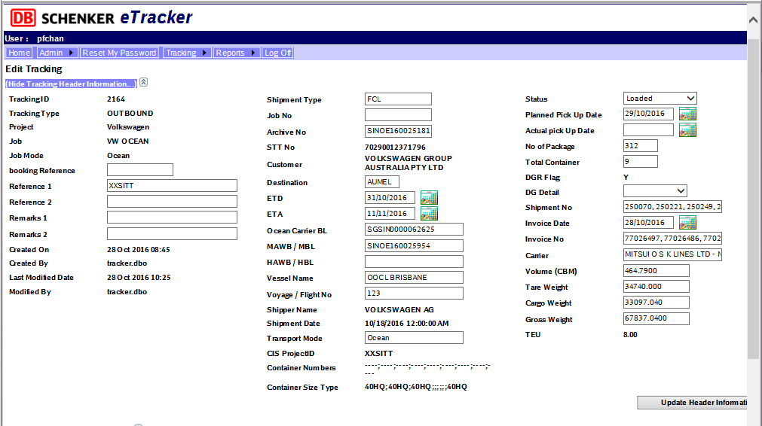

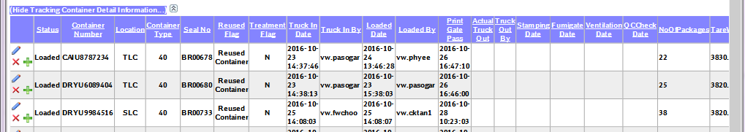

New:

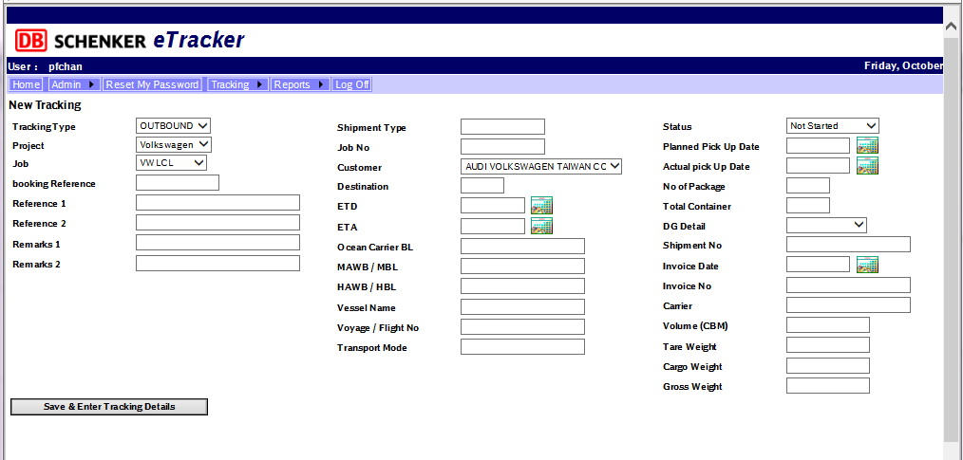

[2017.01.25]

Add Container type:

20RE – 20 ft Reefer

40RE – 40 ft Reefer

